Axicon
Axicon lens also known as conical lens or rotationally symmetric prism is widely used in different scientific research and application. Axicon can be used to convert a parallel laser beam into a ring, to create a non diffractive Bessel beam or to focus a parallel beam into long focus depth.

Axicon is usually characterized by the ratio of the diameter of the ring to the distance from the lens tip to the image plane d/l.

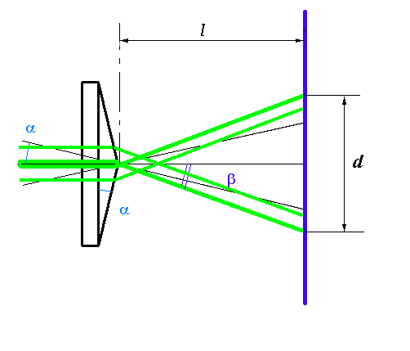

Sample axicon calculations
n*sin α=sin β
For d = 20mm, l = 200mm
tan (β−α) = 10/200 = 0.05
β−α=2.8624°
If n=1.5062 then β−α = (n-1)α = 0.5062*α = 2.86° and α=5.65° β = 8.52°
Cone angle 180°-5.65°*2=168.7°

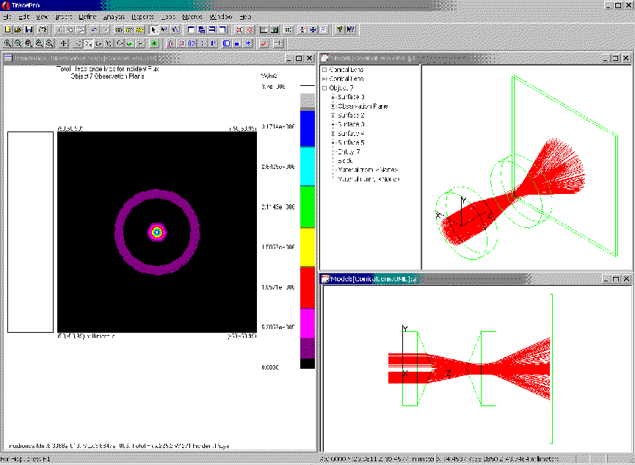

Axicon is used:

In hyperopia correction research using of axicon lens helps to create a doughnut shaped ablation. The Axicon lens is employed in a second step of the LASIK procedure to diverge the broad laser beam allowing the ablation of corneal tissue beyond the 6.5mm optical zone and the creation of a blend zone toward the corneal periphery to approximately 9.5mm.

Researches from Physikalisch-Chemisches-Institut, Heidelberg, Germany use axicon lens in laser diagnostics of the mechanical properties of thin films and solids by surface wave spectroscopy. Laser radiation is focused on the surfaces in concentric ring. Amplitude of the concentric surface acoustic wave generated by the laser pulse will reach maximum value in the center of the ring. Using this approach it’s possible to study mechanical properties of the materials under extreme conditions.
Gottfried Lehmann, Physikalisch-Chemisches-Institut, Heidelberg, Germany
Gottfried.Lehmann@ix.urz.uni-heidelberg.de
More details about Laser diagnostics of the mechanical properties of thin films and solids by surface wave spectroscopy can be found at http://www.uni-heidelberg.de/institute/fak12/PC/hess/frame_members.html

“In our group the axicons will be used to study the conversion of a XeCl laser beam into a non diffractive Bessel beam to generate a laser induced plasma. Also we study the conversion of the beam into a “Light-tube” using the second axicon. Finally we will make an annular focus for a hole drilling application.”
Dr.F.A.van Goor, Quantum electronics group, Department of Applied Physics University of Twente,The Netherlands. e-mail: F.A.vanGoor@tn.utwente.nl

Researcher team at Beckman Laser Institute & Medical Clinic, Irvine, California use the axicon to focus a parallel beam into long focus depth as well as high confined lateral spot to develop a novel optical coherence tomographic (OCT) system.
Zhihua Ding, Beckman Laser Institute & Medical Clinic, Irvine, California
e-mail: zhding@laser.bli.uci.edu

Inphase Technologies researches use axicons is in holographic data storage. They wish to determine the effects of axicons on the Fourier distribution of the random binary data spectrum of a Spatial Light Modulator (SLM).
Research group of Prof. Wendell T. Hill, III at the University of Maryland is focused on creation elements of atom optics, beam splitters and beam switches, out of hollow laser beams. Dark hollow laser beams made using axicons provide an ideal optical trap to channel cold atoms. Visit group web site to see ultra-cold atoms falling under gravity while being confined by a hollow laser beam. Researches also plan to use these guides for enhancing atom interferometers.
Prof. Wendell T. Hill, III group at the University of Maryland http://www.ipst.umd.edu/Hill_Lab/

Research team at St.Andrews University in the UK published an article in the Sept. 12 issue of Nature that describes axicon use in optical tweezers. Optical tweezers are commonly used for manipulating microscopic particles, such as cells, colloids etc. Researches demonstrated that tweezers employing lasers with a Bessel beam profile produced by illuminating an axicon with a gaussian beam, can trap several particles along the beam’s axis.
V. Garcés-Chávez, D. McGloin, H. Melville, W. Sibbett, K. Dholakia
Simultaneous micromanipulation in multiple planes using a self-reconstructing light beam Nature419, 145 - 147 (12 Sep 2002) Letters to Nature
http://www.nature.com/dynasearch/app/dynasearch.taf

