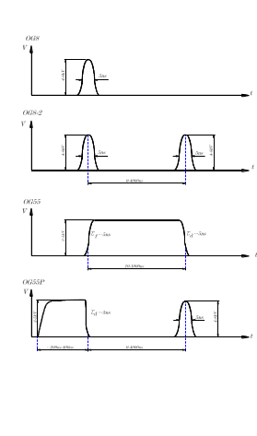
OG8/1, OG12/1
OG8/1-2, OG12/1-2
4-12kV
4-12kV
4-12kV
OG55/1
15
10
OG58P/1, OG612P/1
3-6kV
4-12kV

